Understanding programming basics
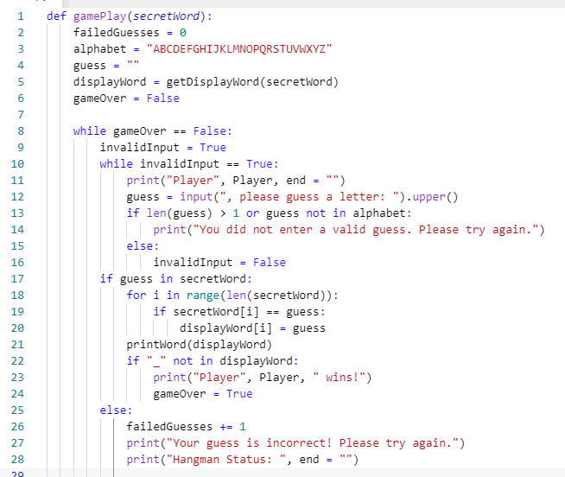

Questions
Read the text below.
Programming structures include sequencing (getting lines in the correct order), selection (if…else), iteration (loops – for and while) and sub programs (procedures and functions).
Data is stored in programs in variables (one piece of data), CONSTANTS (one piece of data that never changes), arrays (multiple pieces of data of the same type) and records (multiple pieces of data of different types).
Data can be of different types: character (1 character), strings (multiple characters. Shown in speech marks). Integers (whole numbers, negative and positive), real numbers (known in Python as floats. These are numbers that include decimcal places), and Booleans (True or False).
Use the code above to answer the following questions:
- What programming structure is defined on line 1?
- Explain secretWord that is inside the brackets on line 1.
- What data type is held in the variable called alphabet on line 3?
- What data type is held in the variable called gameOver on line 6?
- What is the name of the programming structure on lines 10-16?
- What is the sentry variable for this structure called?
- What is the difference between using 1 equals sign (as shown on lines 2-6) and 2 equals signs as shown on lines 8 and 10?
- What affect will .upper() have on the input on line 12?
- Why is .upper() necessary in the context of this program?
- What does > mean on line 13?
- Explain under what circumstances line 14 will run?
- Lines 13 and 14 are an example of data validation. What does it mean to validate data?
- What data structure is shown on lines 13-16?
- What data structure is shown on lines 18-20?
- What does line 26 do?
- Why is elif used on lines 32, 34, 36, 38 and 40 instead of if?
- How many wrong letters can you guess before the game ends?

