Understanding programming basics
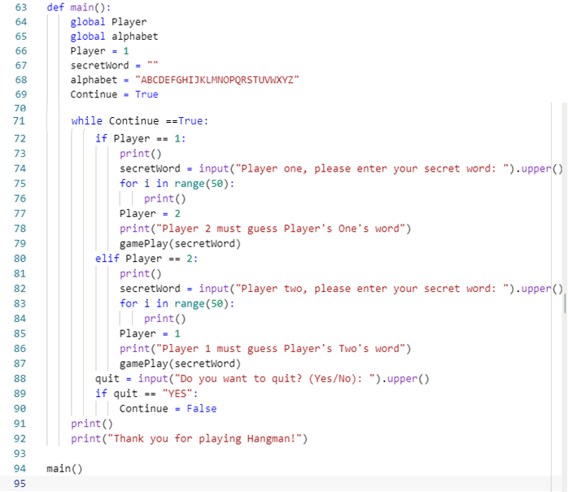

Questions
Read the text below.
Programming structures include sequencing (getting lines in the correct order), selection (if…else), iteration (loops – for and while) and sub programs (procedures and functions).
Data is stored in programs in variables (one piece of data), CONSTANTS (one piece of data that never changes), arrays (multiple pieces of data of the same type) and records (multiple pieces of data of different types).
Data can be of different types: character (1 character), strings (multiple characters. Shown in speech marks). Integers (whole numbers, negative and positive), real numbers (known in Python as floats. These are numbers that include decimcal places), and Booleans (True or False).
Use the code above to answer the following questions:
- What programming structure is defined on line 63?
- What data type is held in the variable called Player on line 66?
- What data type is held in the variable called secretWord on line 67?
- What data type is held in the variable called Continue on line 69?
- What programming structure begins on line 71?
- What is the difference between using 1 = sign, as on lines 66-69, and 2 == signs as on lines 72 and 72?
- What does .upper() do to an input? This is shown on line 74.
- What programming structure is shown on lines 72-87?
- What programming structure is shown on lines 75-76?
- Lines 75-76 and 83-84 will display lots of blank lines on screen as shown by the command: print() How many blank lines will be displayed?
- On line 79 a sub program called gamePlay is called. What is the purpose of the variable secretWord being inside the brackets when the subprogram gamePlay is called? gamePlay(secretWord)
- Line 80 – why is elif used instead of if?
- Explain what line 94 does.

